Course Introduction and Overview Mar 25, 2026
This course focuses on building data lakes using AWS, providing a comprehensive overview of key concepts and practical applications.
Introduction to Data Lakes
- Explains the value proposition of data lakes and differentiates them from data warehouses.
- Discusses the importance of data lakes and introduces their components and architectures.
Data Ingestion and Preparation
- Covers AWS services for storage and data processing, including Amazon S3 and AWS Glue.
- Emphasizes the significance of data cataloging and preparation in the data lake lifecycle.
AWS Lake Formation and Data Processing
- Introduces AWS Lake Formation, its characteristics, and components, with a hands-on lab for practical experience.
- Explores data processing and analytics using AWS Glue, including features like Glue DataBrew and Glue Studio.
The course also includes additional modules on advanced Lake Formation features, modern data architectures, and self-paced labs to enhance learning through practical application.
Venkatesh, welcome to the Building Data Lakes on AWS course! This is the natural evolution of your architecture journey. Since you've already designed a migration for that 3-tier app and Hadoop workload, these concepts will feel like a perfect fit for your "Fidato" data projects.
Here are the answers for your Pre-Assessment:

1. Database Migration
- Answer: AWS DMS (Database Migration Service)
- Why: While SCT (Schema Conversion Tool) helps change the database engine (e.g., Oracle to PostgreSQL), DMS is the actual engine that moves the data itself. It can handle one-time migrations or continuous replication to keep the cloud DB in sync with on-premises.

2. Data Warehouse vs. Data Lake
- Answer: A data warehouse is used for storing structured data, whereas a data lake can store structured, semi-structured, and unstructured data.
- Why: Think of a Warehouse as a library with organized shelves (Schema-on-Write). A Data Lake is a vast reservoir where you can throw in everything—logs, PDFs, images, and SQL tables—and figure out the structure later (Schema-on-Read).

3. Benefits of a Data Lake (Select TWO)
- Answer 1: You can run data in a data lake through machine learning models, as well as stream that data from IoT devices and social media platforms.
- Answer 2: Data lakes give users the ability to harness more data from more sources in less time, and empower users to analyze data collaboratively.
- Why: Data lakes are the foundation for the AI work you love. They allow you to feed "raw" data directly into SageMaker or Bedrock without waiting for a complex ETL process to finish.

4. Basic Data Lake Architecture
- Answer: Amazon S3, AWS Glue, Amazon Athena
- Why: This is the "Serverless Trifecta" of AWS Data Lakes:
  - S3: The storage (The Lake).
  - AWS Glue: The Catalog (knowing what data is where).
  - Athena: The Query Engine (SQL directly on S3).

5. Ad-hoc Queries across Multiple Sources
- Answer: Use Amazon Athena Federated Query
- Why: This is a powerful feature. Instead of moving all your data to one place (which takes time), Athena Federated Query allows you to run a single SQL statement that joins data sitting in Aurora (MySQL), DynamoDB (NoSQL), and S3 (Files) simultaneously using Lambda connectors.
Why Data Lakes? Mar 25, 2026
The content focuses on understanding what a data lake is and its significance in data management.
Definition of a Data Lake
- A data lake is a central repository that stores a vast amount of data, including structured and unstructured formats like text, videos, images, and audio files.
- Unlike traditional databases, data lakes allow for real-time data access and analysis, enabling quicker business decision-making.
Benefits of Data Lakes
- They democratize data access, allowing users to query data directly without needing to go through a data team.
- Data lakes can scale as needed, accommodating large volumes of data without the risk of overflow.
Challenges and Considerations
- Setting up a data lake requires careful planning to handle various data types and ensure data integrity.
- It's essential to implement mechanisms for cataloging, securing, and managing data to prevent the lake from becoming a "data swamp," where data is unmanageable and untrustworthy.
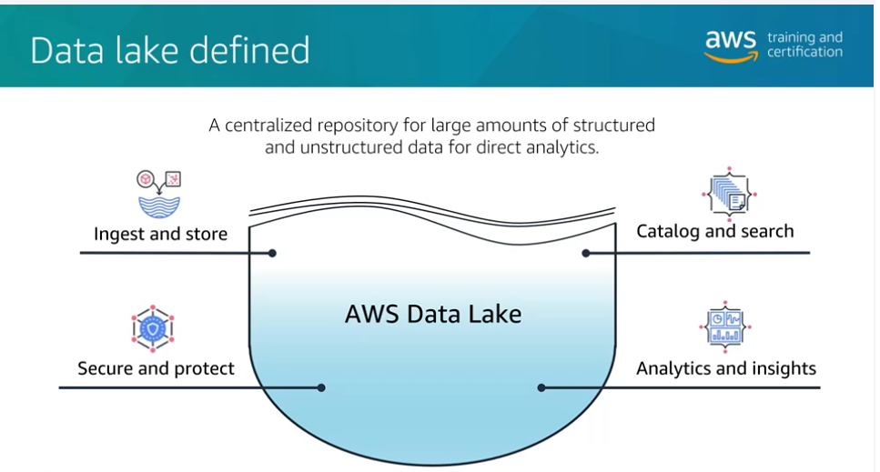

Data Lake vs Data Warehouse Mar 25, 2026
This content explains the key differences between data warehouses and data lakes, highlighting their structures, uses, and cost implications.
Data Warehouse vs. Data Lake
- A data warehouse is a structured relational database designed to hold large amounts of organized data, requiring a predefined schema for data entry.
- A data lake is a non-relational storage system that can accommodate unstructured data from various sources, allowing for flexible data collection without a predefined schema.
Cost and Data Quality
- Data warehouses follow a traditional billing model, incurring costs for storage and performance, which can lead to higher expenses.
- Data lakes offer more cost-effective storage options, typically using services like Amazon S3, with costs incurred mainly during data retrieval and analysis.
Target Users
- Data warehouses are primarily used by business analysts for creating visualizations and reports to support decision-making.
- Data lakes are favored by data scientists for machine learning projects, predictive analytics, and data discovery, although business analysts may occasionally access curated data from lakes.
Components and Architectures Mar 25, 2026
This content focuses on the process of building a data lake and the steps involved in data ingestion and management.
Data Ingestion Process
- Data sources can include databases, IoT devices, and mobile phones, which produce relevant data for the business.
- Solutions like AWS Database Migration Service (AWS DMS) and Amazon Kinesis can be used to ingest data into the cloud.
Data Storage and Cataloging
- Data can be stored in various formats, such as traditional databases or S3 buckets, depending on the structure needed.
- AWS Glue Data Catalog helps in understanding the data structure through schema inference, making it easier to query.
Querying and Visualization
- Amazon Athena can be used to query the data, utilizing the catalog created by AWS Glue for schema-on-read requests.
- Visualization tools like Amazon QuickSight can help present the data in a user-friendly manner for business insights.
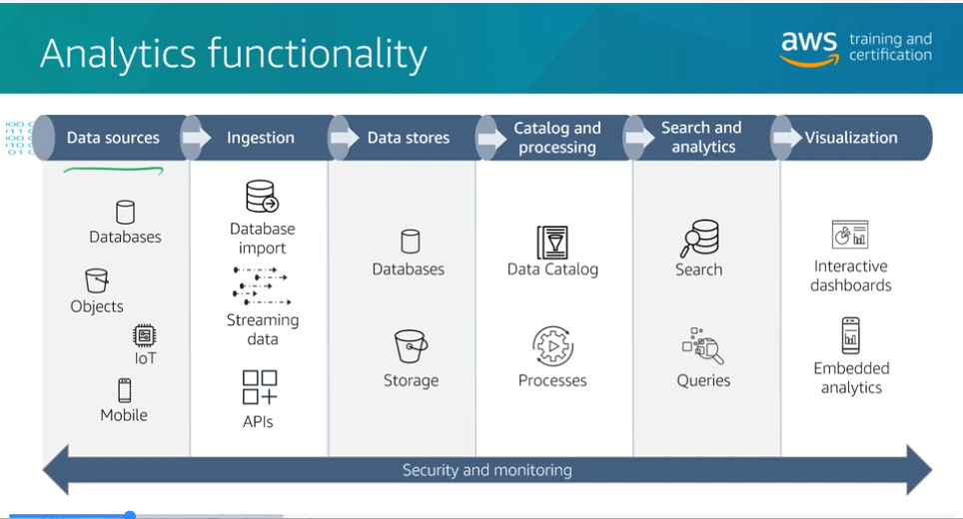

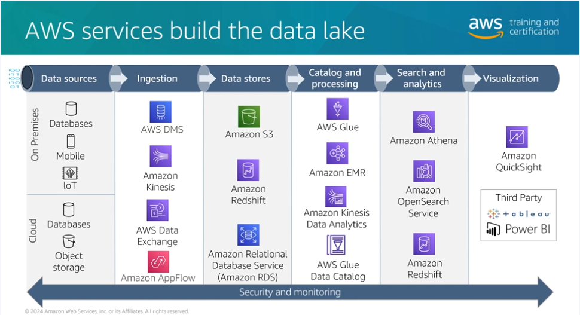

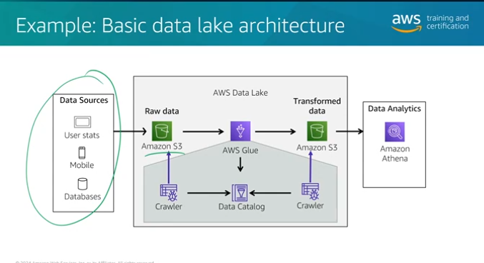

Venkatesh, great job on nailing the Pre-Assessment! These Knowledge Check questions move into the specific architectural layers of a data lake. Since you're balancing your content creation and technical leads, understanding these layers is key to building systems that are both powerful and cost-effective.
Here are the correct answers for your Knowledge Check:

1. Centralized Repository Function
- Answer: Store structured and unstructured data from any source
- Why: The "Lake" in Data Lake refers to its ability to take in everything—JSON logs, CSV tables, images, and even video files from your podcast—regardless of where they come from. It breaks down data silos by putting everything in one place.

2. Most Cost-Effective Storage
- Answer: Amazon S3
- Why: S3 is the "Standard" for a reason. It offers virtually unlimited storage at a fraction of the cost of EBS (block storage) or RDS (database storage). Plus, with S3 Intelligent-Tiering, it can automatically move your older podcast archives to cheaper storage tiers without you lifting a finger.

3. Processing Layer Services (Select TWO)
- Answer 1: AWS Glue
- Answer 2: Amazon EMR
- Why: The Processing Layer is where raw data is cleaned and transformed.
  - AWS Glue: Ideal for serverless ETL (Extract, Transform, Load) jobs to prepare data for analysis.
  - Amazon EMR: Uses big data frameworks like Apache Spark and Hadoop to process massive datasets that would be too large for a single server.
Module Objectives Mar 25, 2026
This course item focuses on the architecture and components of data lakes, particularly in the context of AWS.
Data Lake Architecture
- Data lakes typically consist of layers including data sources, ingestion, storage, cataloging, processing, and analytics.
- While not all data lakes include a visualization layer, the essential components are ingestion, storage, and cataloging.
Key Elements of Data Handling
- Data formatting, partitioning, and compression are crucial for managing large datasets efficiently and cost-effectively.
- These elements help ensure high performance when working with extensive data.
AWS Glue Crawlers and Security
- AWS Glue Crawlers assist in discovering data by inferring data schemas, simplifying the data management process.
- The module concludes with a discussion on security policies and querying data using Amazon Athena, emphasizing the importance of data security in data lakes.
Data Lake Storage Mar 25, 2026
The content discusses the importance of storage in data lakes, particularly focusing on Amazon S3 as a core component.
Storage Importance in Data Lakes
- Data lakes are likened to a giant reservoir for data, with Amazon S3 providing massive scalability, cost-effectiveness, and data durability.
- The separation of storage from compute resources allows for independent scaling and management, enhancing flexibility.
Data Types and Management
- Data transitions from raw to processed, increasing its value; raw data is compared to a rough diamond, while processed data is likened to a fine-cut diamond ready for analysis.
- Amazon S3 efficiently manages various data types, ensuring data lineage and secure storage.
Cost Optimization and Performance
- Features like S3 Storage Class Analysis help optimize storage costs by automating data migration to lower-cost tiers, such as Amazon Glacier for archiving.
- Amazon S3's scalability ensures high throughput and transaction rates, maintaining smooth operation of the data lake.
The content encourages reflection on the benefits of separating storage from compute resources for better scalability and management.
Data Ingestion Mar 25, 2026
The content focuses on the various types of data and the corresponding AWS services for data ingestion into Amazon S3.
Data Types and Ingestion Methods
- Files and Objects: This category includes existing files like images, videos, and documents. AWS services for ingestion include Amazon AppFlow, AWS Transfer Family, and AWS Snow Family, which facilitate secure file transfers and offline uploads.
- Transactional Data: Primarily related to database migrations, this type requires services that can replicate database usage with minimal latency. AWS Database Migration Service (DMS) and Schema Conversion Tool (SCT) are key services for migrating and converting databases.
- Streaming Data: This involves real-time data ingestion, such as IoT sensor data or gaming data. Amazon Kinesis is a managed service for processing streaming data, allowing for real-time ingestion and processing.
The goal is to understand the types of data and the appropriate AWS tools for effective data ingestion into a data lake.
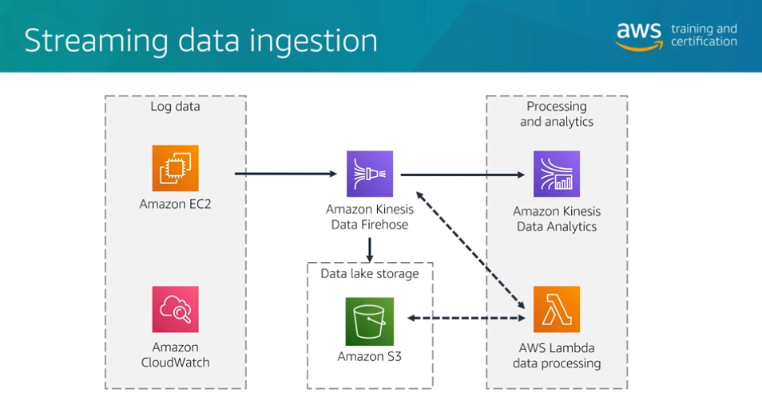

Crawl and Catalog Data Mar 25, 2026
The content focuses on the importance of data discovery and cataloging in managing data lakes effectively.
Data Cataloging
- Organizes and manages vast amounts of data stored in a data lake, enhancing discoverability and metadata management.
- Transforms chaotic raw data into a well-organized and easily accessible resource, preventing potential issues with data management and costs.
AWS Glue Overview
- AWS Glue provides a central metadata repository known as the AWS Glue Data Catalog, which includes features for convenience and control over data.
- The AWS Glue Crawler infers schema from datasets and populates the Data Catalog with metadata, acting as a pointer to the actual data stored in sources like Amazon S3.
Crawler Functionality
- Connects to various data sources using native clients and JDBC drivers, allowing for schema inferencing through built-in or custom classifiers.
- Once the Crawler runs successfully, it updates the Data Catalog with the schema of the data, facilitating better data management and access control.
Demo: Creating and Running a Glue Crawler Mar 25, 2026
The content focuses on using AWS Glue crawlers to infer a schema from a dataset, specifically the New York City Taxi and Limousine Commission data in CSV format.
Data Preparation
- The dataset is stored in an S3 bucket, and the user demonstrates how to list and copy files from this bucket to their local machine for inspection.
- The structure of the CSV file is outlined, including key columns like vendor ID, pickup and drop-off times, and passenger count.
Creating a Glue Crawler
- The user creates a Glue database named "TLC" and sets up a Glue crawler to infer the schema from the copied dataset.
- An IAM role is assigned to allow the crawler to access the S3 bucket, and the crawler is run to create a table in the Glue data catalog.
Querying with Athena
- After the crawler completes, the user accesses Amazon Athena to query the newly created table, which reflects the inferred schema.
- The content emphasizes that the Glue table does not store data but references the location in S3, allowing for metadata management without data loss.
Formatting the Data in the Lake Mar 25, 2026
This course content focuses on best practices for managing data in a data lake environment, particularly when using AWS.
Data Management Best Practices
- Formatting: Proper data formatting is crucial for optimizing storage and improving query performance. Using columnar data formats can significantly reduce I/O operations compared to row-based formats like CSV.
- Performance: Queries against columnar formats are faster, as they require less data to be scanned, leading to lower costs in cloud environments where you pay for resource usage.
Data Storage Solutions
- Raw Data Storage: While raw data should be ingested and stored in its original form, it is often inefficient for querying. Amazon Glacier is recommended for archival storage of raw data.
- AWS Glue: This service can automate the conversion of data into efficient columnar formats like Apache Parquet and ORC, enhancing performance for analytics.
Overall, the content emphasizes the importance of data formatting and efficient storage solutions to optimize performance and cost in data lake architectures.
Partitioning, Compressing, and Compacting the Data in the Lake Mar 25, 2026
The content focuses on common data management practices, specifically partitioning, compression, and compaction.
Partitioning
- This technique involves splitting a dataset into smaller chunks based on query patterns, making data retrieval more efficient.
- For example, instead of storing taxi ride data in monthly files, it can be beneficial to partition it by day to reduce the amount of data scanned during queries.
Compression
- Compression techniques, such as Snappy, LZO, and GZIP, are used to reduce the size of datasets, which can lower storage costs in cloud environments.
- Smaller data sizes lead to reduced monthly storage bills, making compression a valuable practice.
Compaction
- Compaction combines multiple small files into fewer larger files to optimize data retrieval and reduce operational overhead.
- Finding the right balance in file size is crucial; too many small files can slow down queries due to increased API calls, while larger files can improve performance.
Query Data with Amazon Athena Mar 25, 2026
The content focuses on querying data in a data lake using Amazon Athena, a serverless interactive service.
Amazon Athena Overview
- Athena allows users to query data stored in Amazon S3 using standard SQL, requiring no special SDK knowledge.
- It is serverless, eliminating the need for configuration of operating systems or networking.
Cost Efficiency and Best Practices
- Athena charges based on the amount of data scanned; thus, compressing and partitioning data can lead to cost savings.
- Users can save up to 90% on query costs by optimizing data formats and structures.
Integration and Federated Queries
- Athena can be integrated with AWS Lambda and Amazon QuickSight for enhanced data accessibility and visualization.
- Federated queries enable joining data from different sources without needing to copy data to S3, improving data freshness.
AWS Glue and Data Management
- New tables created in Athena appear in the AWS Glue Data Catalog, which manages metadata.
- It's important to specify data locations when creating tables, as deleting a table does not remove the underlying data.
Demo: Querying CSV data with Amazon Athena Mar 25, 2026
The content focuses on querying data using Amazon Athena after creating a table from a CSV dataset.
Querying with Amazon Athena
- The AWS Glue metastore and Data Catalog allow users to create tables from CSV datasets, enabling SQL-like queries.
- Users can preview tables in Athena, which executes a simple SELECT query to verify functionality.
Data Analysis Examples
- The dataset from June 2018 contains over 8 million taxi rides, allowing for various analytical queries.
- Examples include counting trips and calculating average and maximum tip amounts, demonstrating the efficiency of querying large datasets.
Performance Insights
- Each query scans the entire dataset (733 MB), highlighting Athena's capability to handle large volumes of data efficiently, regardless of the specific column queried.
Demo: Columnar data formats with Amazon Athena - a performance and cost comparison Mar 25, 2026
The content focuses on comparing the performance and cost-effectiveness of querying data in CSV format versus Parquet format using Amazon Athena.
Querying Data Formats
- The demo illustrates running the same query on both CSV and Parquet datasets.
- Parquet format is shown to be faster and cheaper due to reduced data scans.
Data Transformation and Storage
- The CSV file size is significantly larger (730 MB) compared to the compressed Parquet files (19 MB).
- The data is stored in Amazon S3, with the Parquet format being columnar, allowing for efficient data retrieval.
Crawler and Query Execution
- A new crawler is created to infer the schema of the Parquet dataset.
- Queries against the Parquet dataset scan less data, resulting in faster execution times compared to the CSV dataset.
This summary highlights the advantages of using Parquet format for data storage and querying in AWS environments.
Demo: Columnar data formats with Amazon Athena - a performance and cost comparison Mar 25, 2026
To transform data to Parquet format, you can use AWS Glue, which provides a serverless data integration service. Here’s a brief overview of the steps involved:
- Create a Glue Job:
  - In the AWS Glue console, create a new job.
  - Choose the source data (e.g., CSV files in S3).
- Select the Target Format:
  - Specify the output format as Parquet in the job settings.
- Define the Data Transformation:
  - Use the Glue ETL (Extract, Transform, Load) script to define any transformations needed for your data.
- Run the Glue Job:
  - Execute the job to process the data and convert it to Parquet format.
  - The transformed data will be saved in the specified S3 location.
- Verify the Output:
  - Check the S3 bucket to ensure the data is now in Parquet format.
This process allows you to efficiently convert large datasets into a more optimized format for querying and storage.
Great work progressing through the Building Data Lakes on AWS modules, Venkatesh! You're now diving into the "pipes and maps"—ingestion, crawling, and querying. Given your interest in multi-vendor AI systems, these tools are what you'll use to feed high-quality data into your agents.
Here are the correct answers for your Knowledge Check:

1. Data Ingestion Services (Select TWO)
- Answer 1: Amazon Kinesis Data Firehose
- Answer 2: AWS Storage Gateway
- Why: Ingestion is about getting data into the lake. Firehose is perfect for streaming data (like real-time logs from your AI agents), while Storage Gateway connects your on-premises environment (like your local files in Tiruchirappalli) directly to S3.

2. Continuous Data Replication
- Answer: AWS Database Migration Service (AWS DMS)
- Why: As we touched on in your earlier Azure modules, DMS is the workhorse for moving databases. It keeps a source (like an on-prem Oracle DB) and a target (S3 or Redshift) in sync in real-time, which is essential for "petabyte-scale" consolidation.

3. Cataloging Your Data
- Answer: AWS Glue Crawler
- Why: A Crawler is the "detective" of the data lake. It scans your S3 buckets, identifies the data formats (CSV, Parquet, JSON), and automatically creates table definitions in the AWS Glue Data Catalog. Without this, your data is just a pile of files; with it, it’s a searchable database.

4. Querying Multiple Stores Without Moving Data
- Answer: Amazon Athena Federated Query
- Why: This is a recurring theme because it's so powerful. It allows you to write a single SQL query that pulls from RDS (SQL), DynamoDB (NoSQL), and S3 (Files) at the same time using Lambda-based connectors. This is the "Zero-ETL" approach.

Architect's Strategy for Venkatesh:
If you're building a dashboard for your Fidato podcast metrics, you wouldn't want to manually upload files. You'd use Kinesis Firehose (Question 1) to stream listener data to S3, run a Glue Crawler (Question 3) to map that data, and then use Athena (Question 4) to instantly see which episodes are trending in Tamil vs. Telugu.
You have plenty of time before the March 27th deadline! Would you like to watch the demo on "Creating and Running a Glue Crawler" next, or are you ready to submit this assignment?
Welcome to Module 3 Mar 25, 2026
This module introduces AWS Lake Formation, focusing on its features, benefits, and security model.
Overview of AWS Lake Formation
- Describes the key features and advantages of using AWS Lake Formation for data management.
- Highlights the importance of Lake Formation in simplifying the process of building and managing data lakes.
Creating a Data Lake
- Explains the steps involved in using Lake Formation to create a data lake.
- Discusses the foundational concepts necessary for understanding data lake architecture.
Lake Formation Security Model
- Introduces the security model associated with AWS Lake Formation.
- Emphasizes the significance of security in managing data access and permissions within a data lake.
AWS Lake Formation Overview Mar 25, 2026
This content provides an overview of AWS Lake Formation, a service designed to simplify the creation and management of data lakes in the cloud.
Introduction to AWS Lake Formation
- AWS Lake Formation automates the setup of data lakes, making it easier to manage data ingestion, storage, and organization.
- It utilizes AWS Glue features like crawlers and the Data Catalog to keep data organized, similar to a library cataloging system.
Key Features of Lake Formation
- Workflow Automation: Lake Formation offers workflow blueprints to streamline common data ingestion processes, reducing complexity for users.
- Security and Access Control: It provides centralized access controls using AWS IAM, ensuring data security through encryption and permission management.
Setting Up a Data Lake
- The setup process involves three main steps: registering storage locations in Amazon S3, creating databases in the Data Catalog, and granting permissions for data access.
- A self-paced lab is included in the course to provide hands-on experience with AWS Lake Formation, enhancing understanding of its functionalities.
AWS Lake Formation Basic Permission Model Mar 25, 2026
The video lecture focuses on understanding permissions in AWS Lake Formation, which is essential for managing data lakes effectively.
Centralized Permission Management
- AWS Lake Formation unifies permissions across various components of the data lake, including analytics engines and the data catalog.
- This centralized approach helps maintain security and compliance by controlling access consistently across all areas.
Fine-Grained Access Control
- Lake Formation provides detailed permissions similar to database permissions, allowing restrictions down to specific tables, columns, and rows.
- This fine-grained control is crucial for governance, compliance, and cost efficiency, as it reduces the need for data replication.
Regulatory Compliance and Monitoring
- With increasing data privacy laws, Lake Formation helps enforce data access policies and supports monitoring and auditing of data access.
- This ensures that organizations are informed about who accessed what data and when, aiding in compliance efforts.
Reading: AWS Lake Formation Basics Mar 26, 2026
The content focuses on AWS Lake Formation, a service that helps manage and secure data lakes for analytics and machine learning.
AWS Lake Formation Overview
- Centralizes governance, security, and sharing of data across analytics and machine learning platforms.
- Facilitates the combination of structured and unstructured data into a single repository by moving data from various sources into Amazon S3.
Permissions Management
- Implements a permissions model that allows fine-grained access control similar to relational databases.
- Enforces permissions at the column, row, and cell levels across various AWS services like Amazon Athena and AWS Glue.
Data Access Workflow
- Involves a series of steps where users request data, permissions are checked, and temporary access is granted for data retrieval.
- Supports hybrid access mode, allowing the use of both Lake Formation and IAM permissions for data management.
Data Transformation Mar 26, 2026
This content focuses on the challenges of managing non-uniform data and introduces AWS Glue as a solution for data transformation.
Data Uniformity Challenges
- Data from different regions can have varying formats, such as date formats and postal codes, leading to inconsistencies.
- Non-uniform data can complicate data analysis and visualization efforts.
AWS Glue Overview
- AWS Glue is an ETL (Extract, Transform, Load) tool that helps clean and organize raw data.
- It automates the process of preparing data for analysis, resulting in a cleaned dataset stored in an S3 bucket.
Data Privacy Considerations
- Different countries have specific regulations regarding data storage and privacy.
- AWS Glue can assist in masking sensitive information, ensuring compliance with privacy requirements.
DataBrew Feature
- DataBrew is a user-friendly, serverless tool within AWS Glue that offers over 250 prebuilt transformations for data cleaning.
- It allows users to perform ETL tasks without managing infrastructure, making data preparation more accessible.
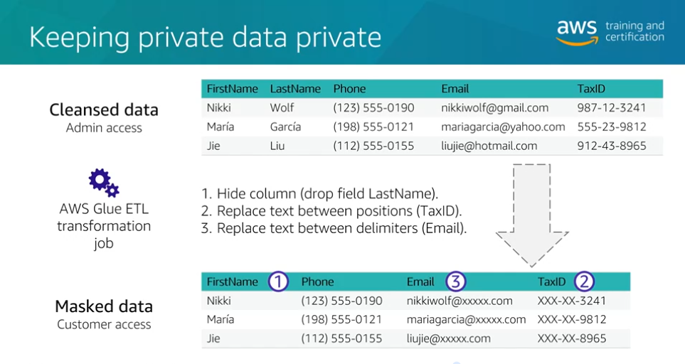

Data Processing with AWS Glue Mar 26, 2026
The content focuses on the capabilities of AWS Glue for data processing, specifically in executing extract, transform, and load (ETL) jobs.
AWS Glue Overview
- AWS Glue simplifies the process of running ETL jobs, which traditionally required complex setups and maintenance of servers.
- It allows users to focus on defining the ETL job rather than managing the infrastructure.
ETL Job Phases
- The extract phase involves querying data sources for new or specific data.
- The transform phase uses Python or Apache Spark to modify raw data into a usable format.
- The load phase involves placing the transformed data into a designated location, such as a database or S3 bucket.
Script Writing Options
- Users can write ETL scripts using the AWS Glue Script Editor for direct coding.
- AWS Glue Interactive Sessions allow the use of Jupyter Notebooks for script editing.
- AWS Glue Studio provides a visual script editor with templates for easier script creation.
AWS Glue Jobs and Workflows Mar 26, 2026
The content focuses on understanding AWS Glue and its functionalities for running ETL jobs.
AWS Glue Jobs
- AWS Glue jobs can be scheduled to run at specific times, on-demand, or conditionally based on events (e.g., new data in S3).
- Scheduling is useful for regular data loads, while on-demand is for infrequent or large jobs.
AWS Glue Workflows
- Workflows allow chaining multiple AWS Glue jobs together for complex data processing tasks.
- An example includes a trigger for new data, followed by jobs for deduplication and formatting, culminating in data cataloging.
Visualization and Error Handling
- AWS Glue workflows provide a visual representation in the console, helping users identify errors and monitor job statuses effectively.
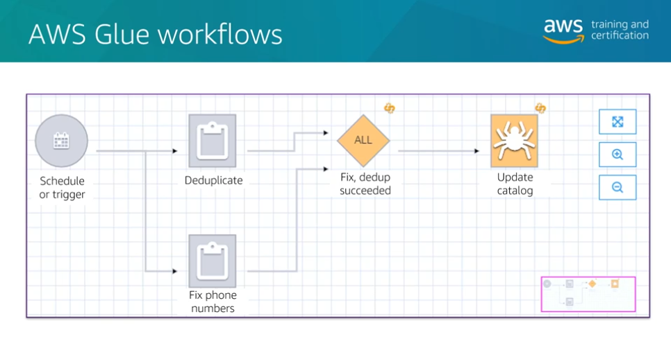
Demo - Glue Databrew Mar 26, 2026
The content focuses on using AWS Glue DataBrew for data cleaning and profiling.
Data Profiling and Setup
- The process begins with importing datasets, such as customer records, and running a data profiler to understand the data structure.
- Users can configure settings to flag duplicate rows and monitor personally identifiable information (PII) within the dataset.
Data Quality Rules
- DataBrew allows the creation of data quality rules to ensure data integrity, such as checking for duplicate rows and zero values in specific columns.
- Users can apply these rules to datasets and create profiles to monitor data quality effectively.
Job Execution and Results
- After setting up the data quality rules, users can run jobs to analyze the data, which provides insights into missing information and potential PII categories.
- The results help identify issues that may require further data transformation, which can be addressed using AWS Glue.
Demo - Glue Studio Mar 26, 2026
This course content focuses on using AWS Glue Studio to create ETL (Extract, Transform, Load) jobs without writing code manually.
Creating an ETL Job
- AWS Glue Studio allows users to visually build ETL jobs using a drag-and-drop interface.
- Users can configure job details, including setting permissions and defining data sources.
Transforming Data
- The visual editor enables users to add steps for data transformation, such as detecting and redacting sensitive information.
- Users can specify patterns to look for, like social security numbers and credit card information, and choose how to handle detected data.
Storing and Cataloging Data
- After transformation, users can configure where to store the cleaned data, such as in an S3 bucket, and choose the format (e.g., JSON).
- The process includes updating the data catalog to create a table for the cleaned dataset, facilitating further analysis.
Tech Talk - Glue / Athena Federated Queries Mar 26, 2026
The content discusses the process of migrating a data lake from on-premises to AWS, focusing on the use of AWS Glue and Athena Federated Queries.
Data Migration Challenges
- The team is transitioning data from on-premises to AWS, facing challenges with split resources.
- AWS Glue Studio is being used for ETL jobs, allowing for a user-friendly drag-and-drop interface.
Using Athena Federated Queries
- Athena Federated Queries enable querying data from both on-premises and cloud sources, allowing for data integration.
- While it provides flexibility, performance may be impacted due to network traversal, especially with large datasets.
Data Security Considerations
- Athena Federated Queries can be secured using Lambda functions within a specified VPC and VPN connectivity for encryption.
- Data encryption at rest and in transit is essential for handling sensitive information, with AWS KMS available for managing encryption on AWS.
This module moves from the "Security" layer of Lake Formation into the "Engine" room of AWS Glue. For an IT professional focused on Data Science and Cloud Computing, understanding how to optimize storage and automate ETL (Extract, Transform, Load) is where you save the most time and money.
Here are the correct answers for your Knowledge Check:

1. Optimizing Query Performance and Cost
- Answer: Apache Parquet and Apache ORC
- Why: These are columnar storage formats. Unlike CSV or JSON (which are row-based), columnar formats allow services like Amazon Athena or Redshift to read only the specific columns needed for a query. This significantly reduces the amount of data scanned, which is how AWS calculates costs for these services.

2. Visual Data Preparation without Code
- Answer: AWS Glue DataBrew
- Why: This is exactly why DataBrew exists. It is a visual data preparation tool that provides over 250 pre-built transformations (like filtering, joining, or normalizing) through a point-and-click interface. It allows users without deep Python or Spark coding skills to clean and prepare data efficiently.
Module Objectives Mar 26, 2026
This course item focuses on using AWS Lake Formation to build data lakes effectively.
Building Data Lakes with AWS Lake Formation
- AWS Lake Formation helps in creating and managing data lakes, streamlining the process of data ingestion, cataloging, and preparation.
- It provides tools for running extract, transform, and load (ETL) jobs to refine incoming data.
Data Security and Permissions
- Ensuring data security is crucial; Lake Formation allows for tagging and managing permissions to control access to data.
- Proper authorization ensures that only the right individuals can access sensitive information.
Data Visualization with Amazon QuickSight
- The course concludes with an introduction to Amazon QuickSight, a tool for creating visualizations, charts, and graphs.
- This tool aids in making sense of the data by providing various ways to visualize and analyze it.
Using Blueprints and Workflows Mar 26, 2026
The content focuses on building data lakes using AWS Lake Formation, highlighting its practical applications and features.
Building a Data Lake
- The concept of building a data lake is likened to digging a hole and filling it with water, emphasizing that while it sounds simple, it requires expertise in practice.
- AWS Lake Formation provides a structured approach to building data lakes, offering blueprints that guide users through the process.
Key Features of AWS Lake Formation
- It integrates with services like S3 and Redshift for data storage, AWS Glue for ETL jobs, and Amazon Athena for querying data.
- Lake Formation automates data cataloging and security, ensuring proper access controls are in place.
Lake Formation Workflows
- Workflows define the specific actions for data extraction, transformation, and loading into the data lake.
- Users select a blueprint, configure data sources, and set up workflows to streamline the data processing and organization.
Fine-grained Access Control Mar 26, 2026
The content focuses on managing access control in data lakes using AWS Lake Formation.
Access Control in Data Lakes
- AWS Lake Formation allows fine-grained access control, enabling specific permissions for users based on their roles.
- For example, marketing teams can access sales records without seeing sensitive customer financial data.
Temporary Credentials and Permissions
- When a user requests data, Lake Formation checks permissions and grants temporary access credentials for data retrieval.
- This process ensures users only access the data they are authorized to see, maintaining data security.
Tagging Strategy for Permissions
- Lake Formation tags, defined as key-value pairs, help manage permissions dynamically and can be assigned to databases, tables, or columns.
- Permissions can be adjusted based on these tags, allowing for flexible access control as data structures change.
Recommended Roles for Access Management
- Suggested roles include IAM administrator, data lake administrator, data engineers, data analysts, and workflow roles for AWS services.
- These roles help ensure proper management and security of the data lake environment.
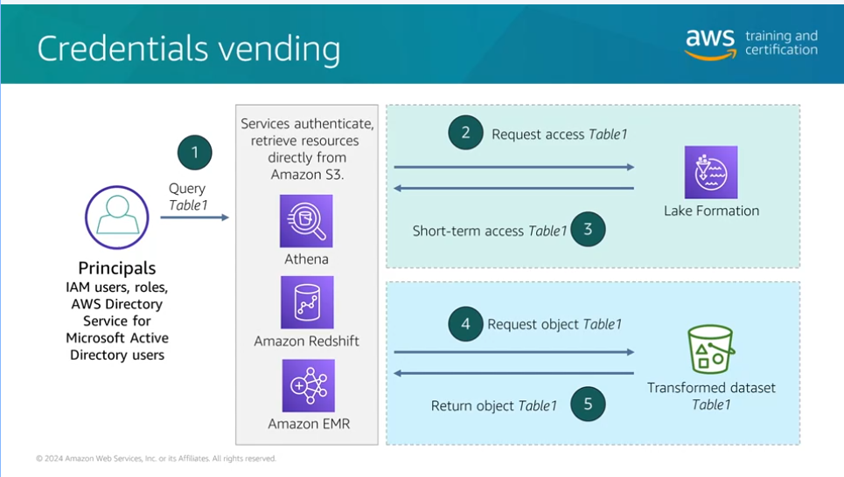
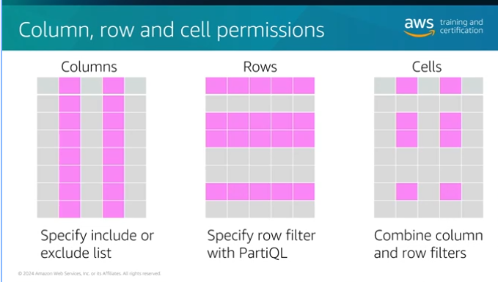
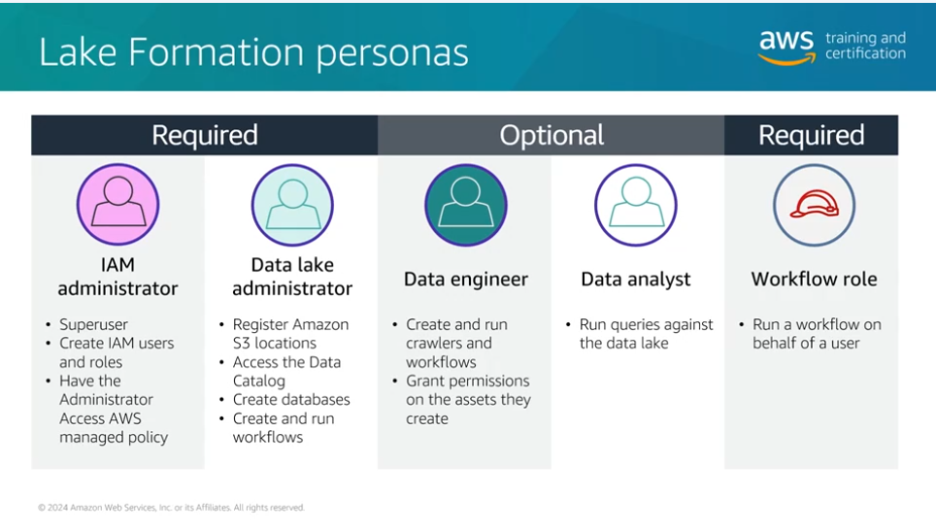

Demo - LF-Tags Mar 26, 2026
The content focuses on managing data access using AWS Lake Formation tags.
Tag Creation and Assignment
- Users can create key-value pairs for data classification, such as "classification" with values "secret" and "not-so-secret."
- Tags must be assigned to datasets to be functional, allowing for better data management.
Editing and Inheriting Tags
- Tags can be edited at the table level, and changes will inherit to all associated data.
- Default values can be set to ensure sensitive data is classified appropriately.
Permissions Management
- Users and groups need permissions to utilize the tags effectively.
- Permissions can be assigned to specific tag values, allowing for controlled access based on user roles.
Visualizing Data with QuickSight - Demo Mar 26, 2026
The content focuses on using Amazon QuickSight, a business intelligence service integrated with AWS, to visualize data from data lakes.
Understanding Amazon QuickSight
- Amazon QuickSight allows users to create charts, graphs, and visualizations from datasets stored in data lakes.
- It is a scalable, serverless service that simplifies data analysis and presentation.
Working with Datasets
- Users can import datasets manually or access them from Amazon S3 buckets.
- QuickSight provides various options for visualizing data, including different types of charts and graphs.
Creating and Sharing Visualizations
- Users can create new visual representations and edit existing ones to analyze data effectively.
- Once visualizations are complete, they can be published and shared with others, making data insights more accessible.
You are moving into the final layers of the data lake stack, Venkatesh! Understanding these Administrative Personas and Visualization Tools is what turns a raw collection of files into a functional, secure business asset.
As someone managing IT projects and certifications, you'll recognize that defining these roles is the first step toward a successful governance strategy.
Here are the correct answers for your Knowledge Check:

1. Required Personas for AWS Lake Formation
- Answer: Data lake administrator
- Why: In the AWS Lake Formation permission model, the Data lake administrator is the foundational persona. This role is responsible for the initial configuration, registering the S3 storage locations, and granting initial permissions to other users. Without an administrator, the granular access controls (LF-Tags) cannot be assigned to other roles like data engineers or analysts.

2. Capabilities of Amazon QuickSight
- Answer: Scalable, serverless business intelligence service
- Why: Amazon QuickSight is the visualization layer. It is "serverless" because you don't manage any infrastructure; it scales automatically to handle thousands of users. It allows you to create interactive dashboards and perform ML-powered insights on top of your data lake (S3/Athena) or data warehouse (Redshift).

Architect's Strategy for Venkatesh:
If you were building the dashboard for your Zenith Finance Tracker, you would use Amazon QuickSight to create the visual charts of income vs. expenses. By setting yourself up as the Data lake administrator, you could ensure that your "Dev Team" has access to the data structure but only you (the owner) can see the actual financial totals in the final dashboard.
You are making excellent progress toward the March 31st deadline! Would you like to dive into how "LF-Tags" simplify managing permissions for hundreds of tables before you start your next lab?
Module Objectives Mar 26, 2026
This module focuses on the concept of modern data architectures, particularly in the context of AWS.
Centralized Data Lakes
- A centralized data lake allows different departments within an organization to access shared information.
- This approach eliminates data silos and ensures that all users have access to the same up-to-date information.
Key Capabilities of Modern Data Architectures
- The module will describe essential features of modern data architectures on AWS.
- It will also cover various approaches to promote enterprise data sharing.
Inspiration from AWS White Paper
- The content is based on a white paper titled "Modern Data Architecture Rationales on AWS."
- This resource provides foundational insights into building effective data architectures.
Modern Data Architecture Mar 26, 2026
The content focuses on modern data architectures and the AWS services that support them.
Scalable Data Lakes
- Amazon S3 is recommended for secure storage of diverse data sets.
- AWS Lake Formation helps in setting up and managing data lakes effectively.
Purpose-Built Analytics Services
- Amazon Aurora and Amazon DynamoDB are suitable for database needs.
- Amazon Redshift is used for data warehousing, while Amazon SageMaker supports machine learning.
Unified Data Access
- AWS Glue is essential for ETL processes, and Amazon Data Firehose aids in data streaming.
- AWS DMS facilitates database migration, and Amazon AppFlow supports SaaS integrations.
Unified Governance
- AWS Lake Formation is preferred for managing data access permissions securely.
- It helps in authorizing and auditing data access effectively.
Performance and Cost Effectiveness
- Techniques like data compression and partitioning are recommended to enhance performance.
- Setting billing alerts helps in managing costs while using AWS services efficiently.
Overall, the lecture emphasizes leveraging AWS services to build efficient and cost-effective data architectures.
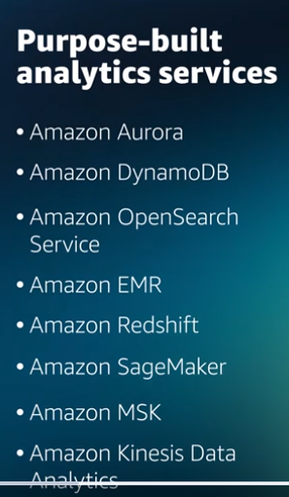
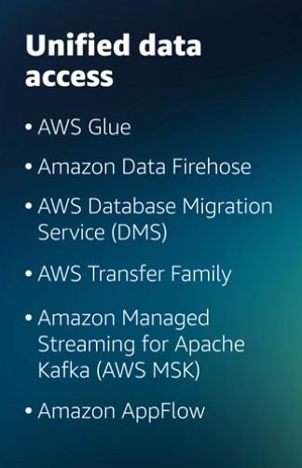

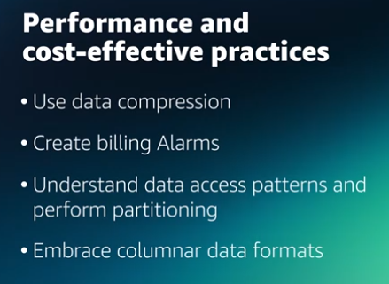

Reading: Modern data architecture Mar 26, 2026
The content focuses on the key components of a modern data architecture on AWS.
Modern Data Architecture on AWS
- It consists of five pillars: scalable data lakes, purpose-built analytics services, unified data access, unified governance, and performance at a low cost.
- This architecture enables customers to build scalable data lakes quickly and utilize a wide range of specialized data services.
Benefits of AWS Modern Data Architecture
- Ensures compliance with data access, security, and governance while allowing for efficient data sharing across organizations.
- Facilitates rapid decision-making with agility and scalability, enhancing overall performance without compromising costs.
Data Movement Scenarios Mar 26, 2026
The content focuses on different data movement scenarios in relation to data lakes, emphasizing the direction of data flow.
Inside-Out Data Movement
- Involves taking data from internal sources and making it available for external use.
- The data lake acts as a centralized source of truth, often sharing processed data with external partners.
Outside-In Data Movement
- Involves ingesting external data into the data lake for internal analysis.
- Useful for incorporating third-party data, with the data lake primarily serving as a processing tool.
Around the Perimeter Data Movement
- Combines elements of both inside-out and outside-in approaches.
- Data can flow directly between services without necessarily passing through the data lake, allowing for efficient data sharing.
Reading: Data Movement Scenarios Mar 26, 2026
The content focuses on the concept of modern data architecture and its role in managing data lakes effectively.
Understanding Modern Data Architecture
- Organizations build data lakes to analyze large volumes of data for deeper insights, integrating data from various silos.
- A modern data architecture combines data lakes, data warehouses, and specialized data stores, enabling unified governance and efficient data movement.
Data Movement Patterns
- Inside-out Data Movement: Data is moved from a data lake to specialized data stores for specific analytics, such as building knowledge graphs.
- Outside-in Data Movement: Data from specialized stores is moved into a data lake for broader analytics, enhancing decision-making.
Perimeter Data Movement
- Data can also be transferred between specialized data stores, such as moving customer profile data from a relational database to a NoSQL database for reporting purposes.
Data Sharing Models Mar 26, 2026
The content focuses on the importance of sharing data across organizations to gain valuable insights and treat data as a product.
Data Sharing and Ownership
- Sharing data across different teams or companies can reveal insights not visible within a single business unit.
- Each team should own their data products, ensuring responsibility for the entire lifecycle from creation to retirement.
Governance and Compliance
- With multiple data products, governance becomes crucial for maintaining data quality and compliance.
- Effective governance includes discovery, reporting, and auditing processes.
Data Mesh Concept
- Data Mesh is an emerging concept that emphasizes treating data as a product and implementing federated governance.
- Amazon Data Zone is introduced as a service that facilitates data management, discovery, and governance across various sources, enhancing data accessibility and utilization.


